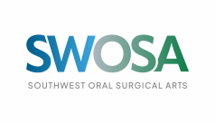

**Health Science Student Award**

**Award Requirements**

Name:_________________________________________

Phone Number:__________________________________ Email:__________________________________________

High School:_____________________________________ GPA:___________________________________________

Graduation Year:__________________________________

Leadership Experience:_________________________________________________________________________________________________________________________

Volunteer Experience: _________________________________________________________________________________________________________________________

**Instructions**

We are proud to announce the Southwest Oral Surgical Arts (SWOSA) Health Science Student Award. The Oral Surgeons & Periodontist at SWOSA are excited to identify and recognize the best Health Science students in Washington County with a $500 award.

To enter, please submit a 250 word essay answering the question of “how you will use your health sciences education to benefit the community.” Please refrain from using AI to assist with the essay. The Deadline for submissions is April 1st, and should be submitted to

[lreber@SWOSA.com](mailto:lreber@SWOSA.com)