**Gastrostomy Tube (G-Tube) Emergency Care**

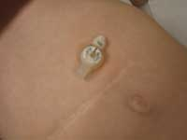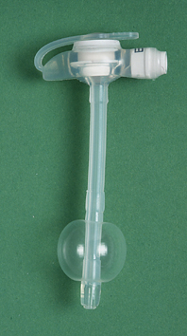

IF A G-TUBE COMES OUT

**It is not life threatening!**

* There may be blood, body fluids or stomach contents around the opening
* Cover the G-tube opening with gauze
* Place the old G-tube in the student’s bag

The parent is usually the first choice

to replace the G-tube

**Follow the Individualized Health Care Plan**