HEAD LICE

Dear Parent/Guardian:

Cases of head lice have been discovered at our school. This handout is to provide you with accurate information about head lice. An infestation of head lice is called pediculosis. Head lice are generally spread by direct head to head contact with a person who already has head lice. Such contact can be common among children during play at home, school, slumber parties and sports activities. Less frequently they may be spread or transmitted by:

- Wearing clothing, hats, scarves, coats, sports uniforms or hair ribbons worn by an infested person;
- Using an infested person’s combs, brushes or towels;
- Lying on a bed, couch, pillow, carpet or stuffed animal that has recently been in contact with an infected person.

A transfer from an infested person, to an object and then to a new person is believed to be relatively rare.

CHECKING YOUR CHILD FOR HEAD LICE
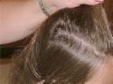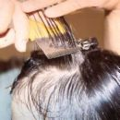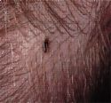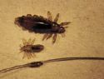 | - Part your child’s hair every ¼ to ½ inch and closely examine the scalp and hair  - Look for nits (eggs) attached within ½ inch of the scalp.  - Look closely behind the ears and at the back of the neck, lice are in these areas frequently.  - Lice are about the size of sesame seeds, watch for movement - lice will move quickly to avoid the light.  - Use a fine-toothed lice comb to comb through the hair from the scalp to the ends of the hair; wipe the comb off or tap it into the sink after each section of hair is combed.  - Nits can be mistaken for dandruff. The difference between a nit and dandruff is that dandruff will flake off easily, but the nit is glued to the hair shaft and will require firm scraping to remove it.  - Nits are laid at the base of the hair and then hatch in 8 days, any nit(s) found more than ½ inch from the scalp have hatched already or is nonviable; what you are seeing attached to the hair are empty egg shells or non viable (dead) nits.  - There are many lice killing products, some available without prescription, that are effective in treating head lice.
For additional information go to the following websites:
- www.cdc.gov/lice/head
- www.headlice.com
- http://choosehealth.utah.gov/prek-12/school-nurses/guidelines/communicable-disease/head-lice.php
- Or contact your school nurse
Revised: 12/17

