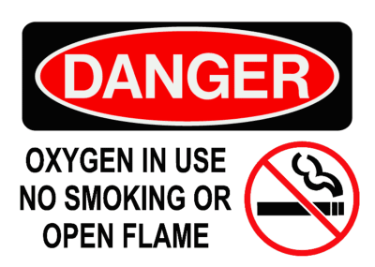

No devices or toys that emit sparks. No aerosol sprays