**Your Epinephrine Injection, 0.3 mg (Auto-Injector) and Epinephrine Injection, 0.15 mg (Auto-Injector)**

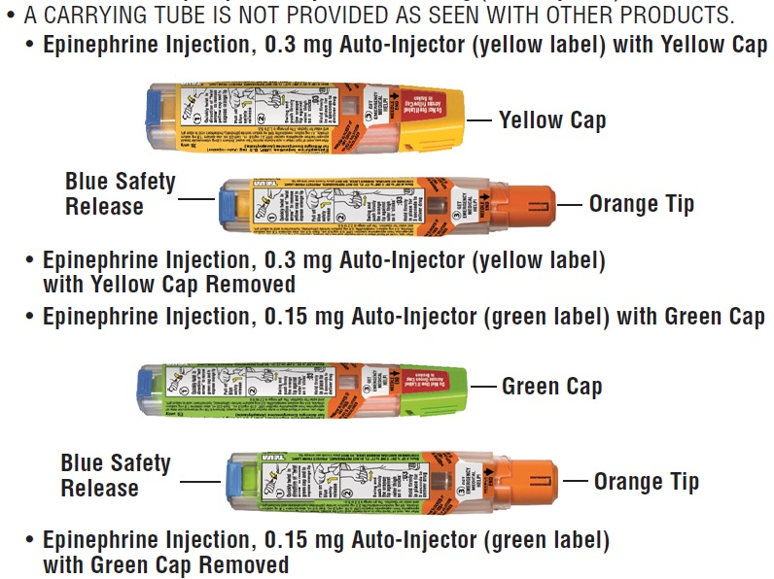

**A dose of epinephrine injection, 0.3 mg or epinephrine injection, 0.15 mg requires 3 steps: Prepare, Administer and Get emergency medical help**

**Step 1. Prepare epinephrine injection, 0.3 mg or epinephrine injection, 0.15 mg for injection**

|  |  |
| --- | --- |
| ppi ifu image 1 | Quickly twist the yellow cap off the epinephrine injection, 0.3 mg auto-injector or the green cap off the epinephrine injection, 0.15 mg auto-injector in the direction of the “twist arrow” to remove it. |
| ppi ifu image 2 | **Grasp the auto-injector in your fist with the orange tip (needle end) pointing downward.** With your other hand, **pull off the blue safety release.** |

**Important: The blue safety release is a small part that may become a choking hazard for children. Throw away the blue safety release immediately after using epinephrine injection, 0.3 mg or epinephrine injection, 0.15 mg.**

**Note:**

* The needle comes out of the orange tip.
* To avoid an accidental injection, never put your thumb, fingers or hand over the orange tip. If an accidental injection happens, get emergency medical help right away.

**Step 2. Administer epinephrine injection, 0.3 mg or epinephrine injection, 0.15 mg**

**If you are administering epinephrine injection, 0.3 mg or epinephrine injection, 0.15 mg to a young child, hold the leg firmly in place while administering an injection.**

|  |  |
| --- | --- |
| 1 | Place the orange tip against the middle of the outer thigh (upper leg) at a right angle (perpendicular) to the thigh. **Swing and push the auto-injector firmly**until it ‘clicks’.  The click signals that the injection has started. |
| 1 | **Hold firmly in place for 3 seconds (count slowly 1,2,3).** The injection is now complete. |
| 1 | **Remove the auto-injector from the thigh.**The orange tip will extend to cover the needle. If the needle is still visible, do not attempt to reuse it. |
| 1 | Massage the injection area for 10 seconds. |