VISION SCREENING

"Children with impaired vision often are not aware of their impairment;
therefore, they do not complain or seek help."
(National Association of School Nurses)

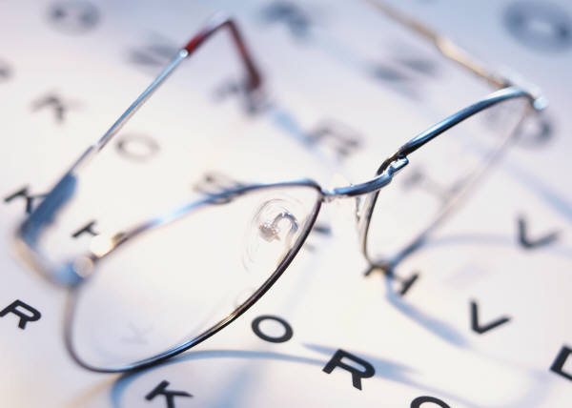

______ ________
Today’s Date

___________________
School

____________________________________
Vision Screening Date

Dear Parent/Guardian

Utah law UCA 53G-9-404 (2019) requires the school district to conduct vision screening for grades pre-K, K, 1st, 3rd, 5th, and 7th, and either 9th or 10th grade each school year. The screening will be conducted using a wall chart and/or photoscreener as needed. If your child does not pass the screening, a referral form will be sent to you.

The results of the vision screening may be shared with other educators and health care professionals to provide appropriate follow-up services.

As per Utah law, if you DO NOT want your child to participate in this screening, you may opt out by returning the attached opt-out form to the school. If you do not return the opt-out form, vision screening will be conducted as mandated by Utah law.

- If your child already has a known visual deficit and you need assistance with getting a pair of glasses, please contact your school nurse or counselor.

