INSTRUCTIONS FOR USE - BAQSIMI™ (glucagon) nasal powder 3 mg
Read the Instructions for Use for BAQSIMI before using it. BAQSIMI is used to treat very low blood sugar (severe hypoglycemia) that may cause you to need help from others. You should make sure you show your caregivers, family and friends where you keep BAQSIMI and explain how to use it by sharing these instructions. They need to know how to use BAQSIMI before an emergency happens.
Tube and Device Parts
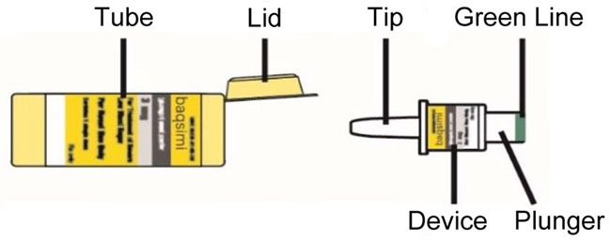
Important Information to Know
- Do not remove the Shrink Wrap or open the Tube until you are ready to use it.
- If the Tube has been opened, BAQSIMI could be exposed to moisture. This could cause BAQSIMI not to work as expected.
- Do not push the plunger or test BAQSIMI before you are ready to use it.
- BAQSIMI contains 1 dose of glucagon nasal powder and cannot be reused.
- BAQSIMI is for nasal (nose) use only.
- BAQSIMI will work even if you have a cold or are taking cold medicine.

Preparing the Dose
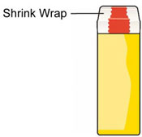 | - Remove the Shrink Wrap by pulling on red stripe.
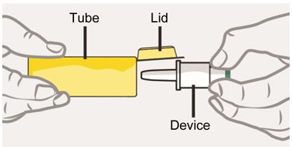 | - Open the Lid and remove the Device from the Tube.  Caution: Do not press the Plunger until ready to give the dose.
Giving the Dose
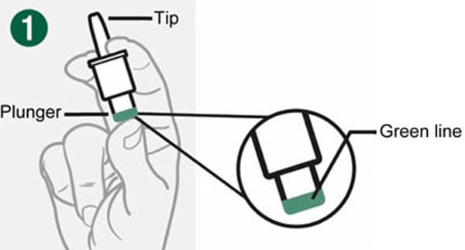 | - Hold Device between fingers and thumb.  - Do not push Plunger yet.
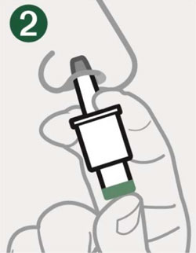 | - Insert Tip gently into one nostril until finger(s) touch the outside of the nose.
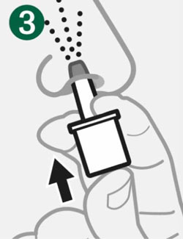 | - Push Plunger firmly all the way in.  - Dose is complete when the Green Line disappears.
After giving BAQSIMI
- Call for emergency medical help right away.
- If the person is unconscious turn the person on their side.
- Throw away the used Device and Tube.
- Encourage the person to eat as soon as possible. When they are able to safely swallow, give the person a fast acting source of sugar, such as juice. Then encourage the person to eat a snack, such as crackers with cheese or peanut butter.
- If the person does not respond after 15 minutes, another dose may be given, if available.
Storage and Handling
- Do not remove the Shrink Wrap or open the Tube until you are ready to use it.
- Store BAQSIMI in the shrink wrapped Tube at temperatures up to 86º F (30ºC ).
- Replace BAQSIMI before the expiration date printed on the Tube or carton.
