**How to use *neffy***

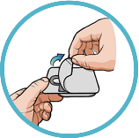**1**

**Remove**

**Remove *neffy* from packaging.** Pull open the packaging to remove the ***neffy*** nasal spray device.

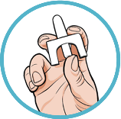**2**

**Hold**

**Hold device as shown.** Hold the device with your thumb on the bottom of the plunger and a finger on either side of the nozzle.

* **Do not pull or push on the plunger.**
* **Do not test or prime (pre-spray). Each device has only 1 spray.**

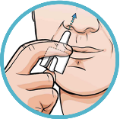**3**

**Insert**

**Insert the nozzle into a nostril until your fingers touch your nose. Keep the nozzle straight** into the nose pointed toward your forehead.

* **Do not** point (angle) the nozzle to the nasal septum (wall between your 2 nostrils) or outer wall of the nose.

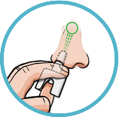**4**

**Press**

**Press plunger up firmly until it snaps up and sprays liquid into the nostril.**

* **Do not** sniff during or after the dose is given. If any liquid drips out of the nose, you may need to give a second dose of ***neffy*** after checking for symptoms.