
Washington County School District Health Services

Gastrostomy Tube Management

Information for Teachers and Teachers Aides

5-26-11 SC, Adapted from “Gastrostomy Tube Management”, www.education.tas.gov.au

GASTROSTOMY TUBE MANAGEMENT

Welcome to the Washington County School District Health Services. This Gastrostomy Tube Management Training Package is designed to assist teachers and teacher aides who are assigned to look after a child with a gastrostomy tube in place.

To successfully complete the Gastrostomy Tube Management Training Package, participants must complete the following two requirements:

- Watch the Gastrostomy Tube Training Module on the district health services site.
- Get signed off by a nurse for the Competency Assessment found on page 10
All the information required to complete the training program is contained in this booklet. For any queries relating to the program, please do not hesitate to contact your school nurse.

TABLE OF CONTENTS
Content | Page Number
Gastrostomy Tube Management | 1
General Information | 2
Feeding Considerations | 3
Troubleshooting | 4
Medication Considerations | 5
Care of the Tube Site | 6
Venting/Decompression | 7
Care Plan Information | 8
Feeding Regimen | 9
Competency Tool | 10

GENERAL INFORMATION

“Gastrostomy” refers to the surgical creation of an artificial opening into the stomach or jejunum through the abdominal wall. A gastrostomy is performed when a person is unable to eat normally, due to illness, injury or disability.

Tube feeding is an excellent way to ensure that a person who cannot eat normally receives adequate nutrition. Tube feeding goes directly into either:
- the stomach, through a gastrostomy tube (PEG or G-tube)
- the jejunum (a section of the small intestine), through a jejunostomy tube (PEJ or J-tube)

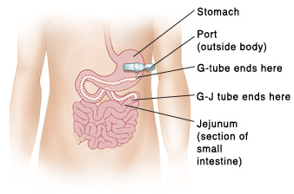

Tube feedings are given on two types of schedules:

- Continuous feeding – where the formula drips through the feeding tube all day or all night (or both)
- Intermittent feeding – where larger amounts of the formula are given 3 – 8 times a day.

The person’s Medical Practitioner decide upon the feeding schedule and type of diet required.

FEEDING CONSIDERATIONS

Feedings should be given only when the person is sitting upright, propped up at ≥ 30°, or while standing.

IMPORTANT
DO NOT have the person lay flat during the feeding
WAIT for one hour after the feeding before lying flat.

Lying down can cause the person to cough and/or vomit. This can easily lead to aspiration and further complications.

WARNING
If the person starts to cough,
choke during a feed,
or have difficulty breathing,
STOP the feeding
Call 911 and the parent immediately!

There are three different ways to deliver tube feedings:

- Gravity feeding: Formula is administered from a container suspended from an IV pole above the individual – the formula flows through the tubing due to the effect of gravity.

- Pump feeding: A mechanical pump delivers the formula under pressure.

- Bolus/Syringe feeding: Formula is administered via a 60mL catheter tipped syringe.

Please follow the instructions given by the Medical Practitioner.

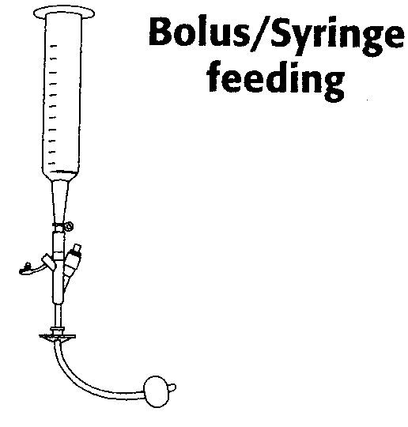 | 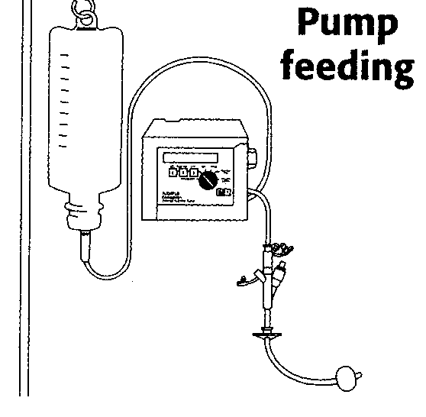 | 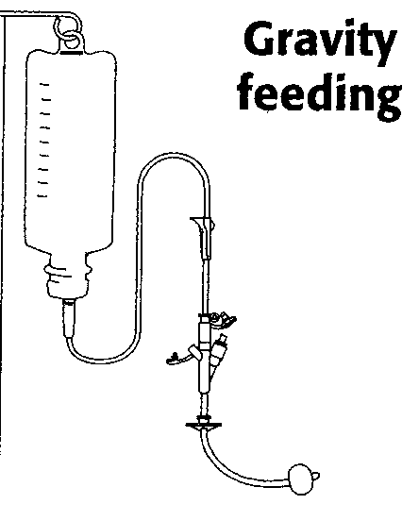

TROUBLESHOOTING

Some common problems that can occur with feeding tubes are listed below. Please refer to these procedures if you experience a problem with a feeding tube. If the problem continues, contact the parent or a health care professional.

Blocked Tube

- Insert a 30 – 60mL syringe into the end of the tube.
- Pull back the plunger and withdraw as much fluid as possible.
- Take the syringe out of the tube and discard the withdrawn fluid.
- Insert a syringe with 10mL warm water into the end of the tube. Moving the plunger back and forth put a little water into the tube.
- If the tube does not clear, clamp the tube for 5 to 15 minutes.
- Fill the syringe with 10mL warm water. Try again to flush the tube.
- Repeat the procedure or call the parent or health care professional if you are unable to clear the tube.

Tube Partially Out

- Do not use the feeding tube if it looks like it has come partway out of the tube site. Refer to the measurements/markings you have recorded.
- Call the parent or a health care professional immediately. In the event that the parent or health professional is unavailable, go to the Emergency Department of your preferred hospital.
- Until you get help from a doctor, keep the tube in place by taping it to the skin.

Tube Completely Out

- If the tube is out it must be replaced. Otherwise, the opening to the stomach or intestine will begin to close within one to two hours.
- Cover the tube site with a small gauze dressing and tape to skin.
- Contact the parent or your health care professional, or go to the Emergency Department of your preferred hospital as soon as possible. Please remember to take the tube with you - this will ensure that the replacement tube is same type.

MEDICATION CONSIDERATIONS

Remember: medications must only be administered by an appropriately trained person.
- If a tablet must be crushed, or a capsule opened, put on gloves, and do not inhale the fine powder particles.
- NEVER crush enteric-coated or timed-release tablets or capsules.
- NEVER mix medication with tube feeding formula.
- NEVER mix medications together – give them one at a time.

Medication Administration
Most medications can be given via the feeding tube. It is recommended that:
- Liquid medication is used whenever possible (suspensions/elixirs).
- If a tablet must be crushed, be sure to crush it into a fine powder and mix it well in warm water.
- The tube is flushed with 10mL of warm water before and after medication administration.
If more than one medication is to be given, give each separately and flush the tube with 5mL of warm water between medications.

There are a number of medications that must be separated from enteral feedings (feeding directly into GI tract through a tube). This will involve turning the feeding OFF for one hour before the dose, and NOT resuming the feeding for at least one hour after the medication has been given. Follow the Individualized Health Care Plan.

CARE OF THE TUBE SITE

It is important to check the tube site every day. Please contact the parent or a health care professional as soon as possible if you notice any of the following:
- Redness
- Pain or soreness
- Swelling
- Unusual drainage around the tube (such as bloody, odorous, or formula-like drainage

It is normal to have a small amount of serous (clear or watery fluid) ooze around the tube site, which may make the skin red. Granulation tissue or ‘proud flesh’ (soft pink fleshy projection of skin) is often present, particularly in children. Unless it is painful, there is no need to have it treated.

If the tube site needs to be cleaned, please wash your hands and wear gloves. Clean the area under the gastrostomy tube flange with warm water using cotton tipped swab or face washer/gauze.

VENTING / DECOMPRESSION

Abdominal discomfort and bloating may be caused by excessive air/gas in the stomach. Allowing the air to escape is called venting or decompression. The venting process will only take a couple of minutes and should be performed prior to each feed or medication administration.

PEG and Gastrostomy Tubes with Balloon
- Remove cap from the feeding port and attach a 60ml catheter tip syringe to the feeding port.
- Lower the syringe below the stomach.
- Allow contents and air (froth and bubbles) to fill the syringe.
- Drain the contents back into the stomach by raising the syringe above the stomach.

Low Profile Stomate
- These devices have a non-reflux valve in the tip of the tube which prevents the stomach contents refluxing up the tube and spilling from the feeding port.
- A decompression tube is inserted into the stomata, which opens the non-reflux valve and allows the air to escape.

Hide-A-Port
- Connect the straight extension tube to the feeding port.
- Attach a 60ml catheter tip syringe to the extension tube and lower the syringe below the stomach.
- Allow the stomach contents and air to fill the syringe.
- Drain the contents back into the stomach by raising the syringe above the stomach.

Washington County School District Health Services

GASTROSTOMY TUBE FEEDING CARE & COMPETENCY

STEPS FOR GASTROSTOMY TUBE FEED | KEY POINTS | ACHIEVED | NEEDS REVIEW
- Identify the person requiring the feeding and check care plan for:  - Person’s name.  - Type and rate for feeding to be delivered.  - Any specific instructions | Ensures the right person receives the feeding  Ensures the right feeding is delivered and all specific instructions are adhered to.
- Wash hands thoroughly with soap and towel dry. | Maintain standard precautions as per infection control recommendations.
- Prepare equipment and feeding:  Check expiration date on formula,  Have feeding system ready, water &10cc syringe for flushing | Ensures feeding is safe to use.  Different gastrostomy tubes and feeding systems are used.
- Prepare the person for feeding  - Explain procedure  - Respect privacy  - Ensure the person receiving the feeding is in s semi-reclined or upright position. | Reduces the risk of reflux.
- Vent or decompress tube as per care plan. | Prevents abdominal bloating and discomfort by allowing air to escape prior to feeding. Different gastrostomy tubes require a different method for venting/decompressing.
- Prime feeding line, prepare syringe, remove safety plug and connect adaptor or line, flush tube with water. | Line is primed and free from air.
- Administer feeding as per care plan. | Raising or lowering feeding container or syringe can alter rate of flow.
- Flush tube with water when feeding complete. | Prevents tube blocking.
- Remove line and connectors and replace safety plug.
- Leave person clean and comfortable and in the upright position for 30 minutes following feeding | Reduces risk of reflux.
- Wash equipment in warm soapy water, rinse and allow to dry.
- Document on care plan. | Legal record of information.

Signature of Trainee _____________________________________________ Date ________________

Signature of School Nurse ________________________________________ Date ________________

