How to use neffy
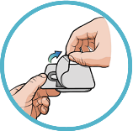1
Remove
Remove neffy from packaging. Pull open the packaging to remove the neffy nasal spray device.
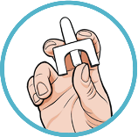2
Hold
Hold device as shown. Hold the device with your thumb on the bottom of the plunger and a finger on either side of the nozzle.
- Do not pull or push on the plunger.
- Do not test or prime (pre-spray). Each device has only 1 spray.
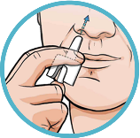3
Insert
Insert the nozzle into a nostril until your fingers touch your nose. Keep the nozzle straight into the nose pointed toward your forehead.
- Do not point (angle) the nozzle to the nasal septum (wall between your 2 nostrils) or outer wall of the nose.
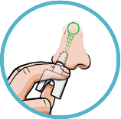4
Press
Press plunger up firmly until it snaps up and sprays liquid into the nostril.
- Do not sniff during or after the dose is given. If any liquid drips out of the nose, you may need to give a second dose of neffy after checking for symptoms.

